**FastEddyScript toolbox**

**Data Requirements**

Building Footprints

* <https://gis-fema.hub.arcgis.com/pages/usa-structures>
* <https://github.com/microsoft/USBuildingFootprints>
* \\gisData.ucar.edu\data\FacilitiesAndCriticalInfrastructure\buildings

LiDAR

* <https://apps.nationalmap.gov/lidar-explorer/#/>
* Local State, County, or City GIS offices
  + Texas Natural Resources Information Systems - https://tnris.org/stratmap/elevation-lidar/

Elevation

* \\gisData.ucar.edu\data\ElevationAndDerivedProducts
  + SRTM - \\gisData.ucar.edu\data\ElevationAndDerivedProducts\SRTM\srtm_void_filled\elevation\srtm_n_elev_w.jp2"

Land Cover

* NLCD - \\gisData.ucar.edu\data\BiologyAndEcology\Landcover_NLCD
  + https://www.mrlc.gov/data

Land Use

FastEddy Toolbox - “dallas_jan2023\BuildingHeights\customToolbox\FastEddy.pyt"

# Create Domain Polygon

1. get the namelist file and identify the center lat and lon
2. create a new point feature class for that lat and lon – make the projection wgs84
3. use this website if you need to convert between decimal degree and degrees min sec
4. project the point to the projection in the namelist file – lambert conformal conic with parameters from file
   1. In the project tool go to the output coordinate system click on the world
   2. Click on create new projected coordinate system
   3. 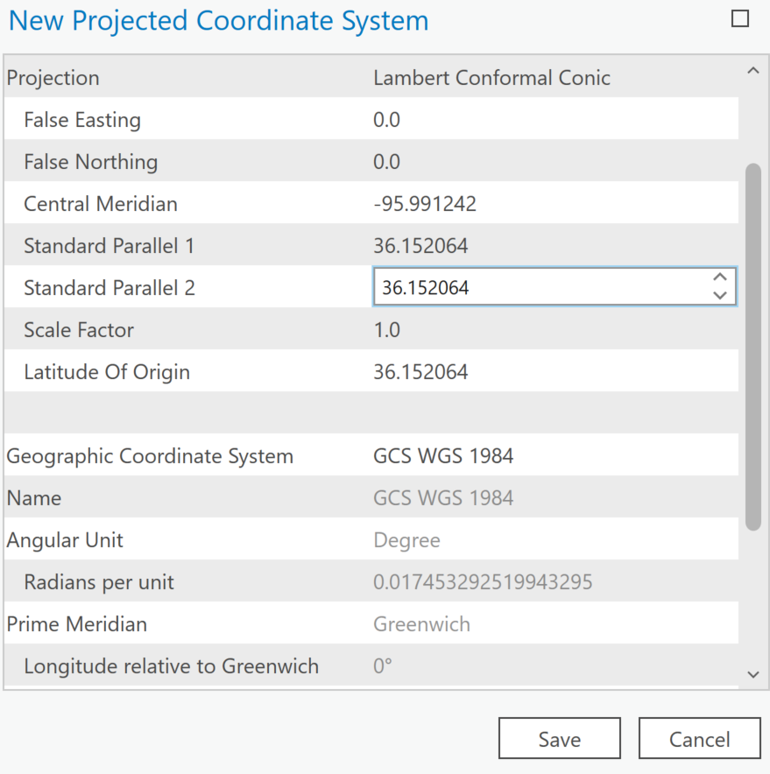
   4. Buffer by 2.5 km
   5. Feature envelope to polygon – to get the square domain

Create the corner locations in Lambert and Geographic

1. Feature Vertices to Points – to create the 4 corner points
2. Add XY coordinates to add the X and Y in Lambert
3. Add field lat and lon and Calculate Geometry

Download the Lidars that fall within the domain.

# Running Tool

1. Create a new ArcGIS Pro project
2. Create the following directories in Catalog pane in ArcGIS pro
   * Final
3. Copy the customTool, lidarTools, all Lidar data into your ArcGIS Pro project
4. Create the following empty geodatabases:
   1. finalGrids
   2. scratch
5. Install Toolbox in ArcGIS Pro
6. Open ArcGIS Pro and create a new project or open an existing Project
7. In the Catalog Pane, right click on Toolboxes and select Add Toolbox

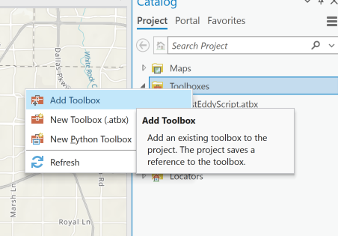

1. Navigate to the customToolbox directory and select FastEddy.pyt. Click Ok.

# Step 1 : Create Building Surface from LiDAR

This tool requires a directory with a bunch of .laz files. It will unzip the .laz files to .las files and then merge them together into a .lasd file. Then the tool will create a Digital Terrain Model (DTM), Digital Surface Model (DSM), and a normalized Digital Surface Model (nDSM).

|  |  |
| --- | --- |
| **LiDAR EXE Directory from LiDAR Tools**  This is the directory where laszip.exe is located. This can be downloaded from https://rapidlasso.com/lastools/ This .exe will convert the downloaded .laz files to .las files. |  |
| **Directory where LAS data is stored**  This is the directory where you have downloaded and stored the LiDAR .laz files which you have already downloaded. |
| **Output Geodatabase to store surface data**  You must have a geodatabase already created to store your files. This can be a scratch geodatabase but is where all outputs will be stored. |
| **Output LiDAR (lasd) file**  Name of output lasd file and direcotry. The lasd will be the merged LiDAR files from the input LiDAR directory. |
| **Input domain name**  You specify what the domain name will be for your project. This will be applied to all outputs. Example Downtown or FortWorth. |

# Step 2: Add Height to Buildings

This tool will take the nDSM you created in Step 1 and perform a zonal statistics with the buildings dataset. The output will be a gridded dataset with the buildings and their heights

* 1. Map a Network Connection to //gisdata.ucar.edu/Data
  2. Bring in the Oklahoma Buildings – FacilitiesAndCriticalInfrastructure/buildings/Oklahoma
  3. Select buildings that fall within the domain and same locally – so you are just working with buildings in Domain – small and faster

|  |  |
| --- | --- |
| **Input Surface Data**  This is the nDSM that you created in Step 1 | Buildings with Height output overlaid on top of the LiDAR lasd file. |
| **Input Building Height Data**  Building footprints that you have already downloaded from FEMA or Microsoft or a local GIS office. |
| **Input Domain name**  This should be the same name you used in Step 1 for consistency. IE Downtown |
| **Final Output Directory**  This should be a directory that will store the .csv and the domain corner excel file. |
| **Output Projection File**  You may want the projection to match the WRF projection. You can create a shapefile that is projected to this WRF projection. Everything will get projected to this projection. |
| **Scratch Directory**  A geodatabase that will be used to store scratch data. |
| **Domain File**  A vector dataset that has the rectangular domain. Everything will get clipped to this extent. |
| **Geodatabase to store final Gridded data**  A new geodatabase to store all the clipped and projected data before they get converted to .csv. |

# Step 3: Project, Clip and Convert

This step will take buildings, land cover, land use, and elevation and project it to the WRF projection, clip it to the domain, and convert it to .csv. Everything will be stored in the final directory you specify

Clip elevation and NLCD to a smaller domain before proceeding to this step.

* + - 1. Zoom into your domain
      2. Bring elevation and NLCD into map
      3. Right click on the layer > Save AS

|  |  |
| --- | --- |
| **Input Building Data**  The building height raster data that was created in Step 2 |  |
| **Input Land Cover Data**  Do not use the CONUS level NLCD. First clip the land cover to a smaller domain and use that as the input. It will get resampled to 1m, projected, and clipped to the domain. |
| **Input Elevation Data**  Do not use the CONUS level elevation. First clip the land cover to a smaller domain and use that as the input. |
| **Input Land Use Data**  Do not use the CONUS level NLCD. First clip the land cover to a smaller domain and use that as the input. |
| **Input domain file**  The domain as a vector dataset - used in Step 2 |
| **Input projection file**  File that is projected to the WRF projection - used in Step 2 |
| **Final Output Directory**  The directory where you want all your .csv files stored. - used in Step 2 |
| **Scratch Output Directory**  Scratch geodatabase to store intermittent data |
| **Geodatabase to store final Gridded Data**  The geodatabase to store the projected and clipped gridded data that will eventually be converted to .csv. |